**COMPARATIVE ANALYSIS ON IMAGE CLASSIFICATION USING MACHINE LEARNING AND DEEP LEARNING**

* **Abstract**
* To classify various images based on their facial features and train model to predict the images with good accuracy.
* The training dataset of the model takes place with usage of Haarcascade and Local Binary Pattern for classifying the images based on their facial features.
* To design a UI (USER INTERFACE) page to validate the images to check whether our model performed well or not.
* **Motive**
* To prove that ML techniques performs well for classifying the images when compared to deep learning techniques.
* To create a UI to for validating various images based on their facial features and to check their accuracy score.

**Block Diagram**

* **Data Set**
* The data set consists of 6 cricket persons images in different folders with their names.
* The data set having around 700 to 900 images in total.
* Each folder in the data set consists around 150 to 200 images of a particular person.
* **Preprocessing**
* Normal image

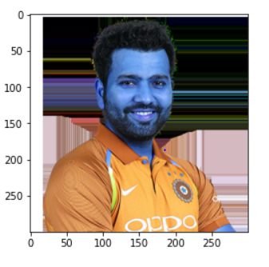

**Normal Image**

* The normal images are converted into grey code.

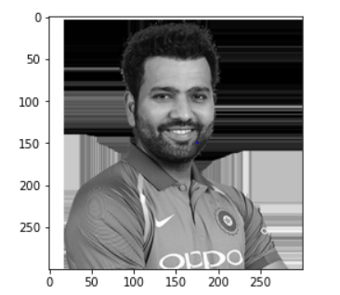

**Grey Image**

* The data set will have image that images will be classified into 2 categories:

1. Perfect face which eyes are clearly visible
2. Faces which eyes are not visible.

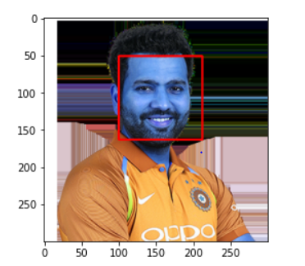

**Detecting the face in the image**

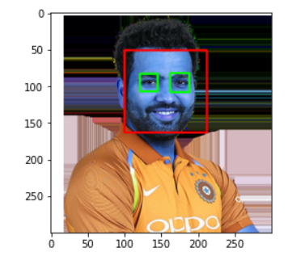

**Detecting eyes along with face**

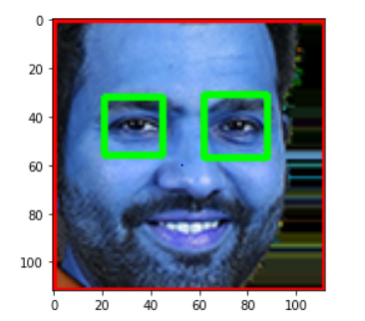

**Cropped image having only face and eyes**

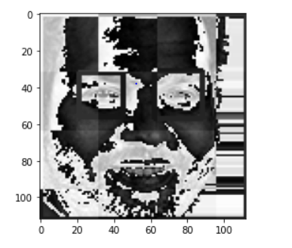

**Facial feature extraction of the cropped image**

* These cropped images will be converted into grey code along with feature extraction using **PYWAVELETS** and then goes for training and testing around 300 to 500 images.
* The images count will be reduced because the initial data set may not have all the images which eyes and face clearly visible so, the model takes only the images having perfect and eyes visible into the consideration.
* **Classification**
* Now the cropped images under goes for training and testing with different machine learning classifiers and different deep learning techniques.
* **Optimization**
* Usage of different optimization techniques like randomized search cv, grid search cv etc. to improve the accuracy of the model for ML and usage of different optimizers like Mish, Adam, SGD etc. for Deep Learning.
* **Results**
* To prove that ML performs well with good accuracy for classifying the images when compared to DL.
* **Web Page Results**
* A drop zone box is available in the web page a validation images has been chosen and uploaded in the drop zone box and click on classify.

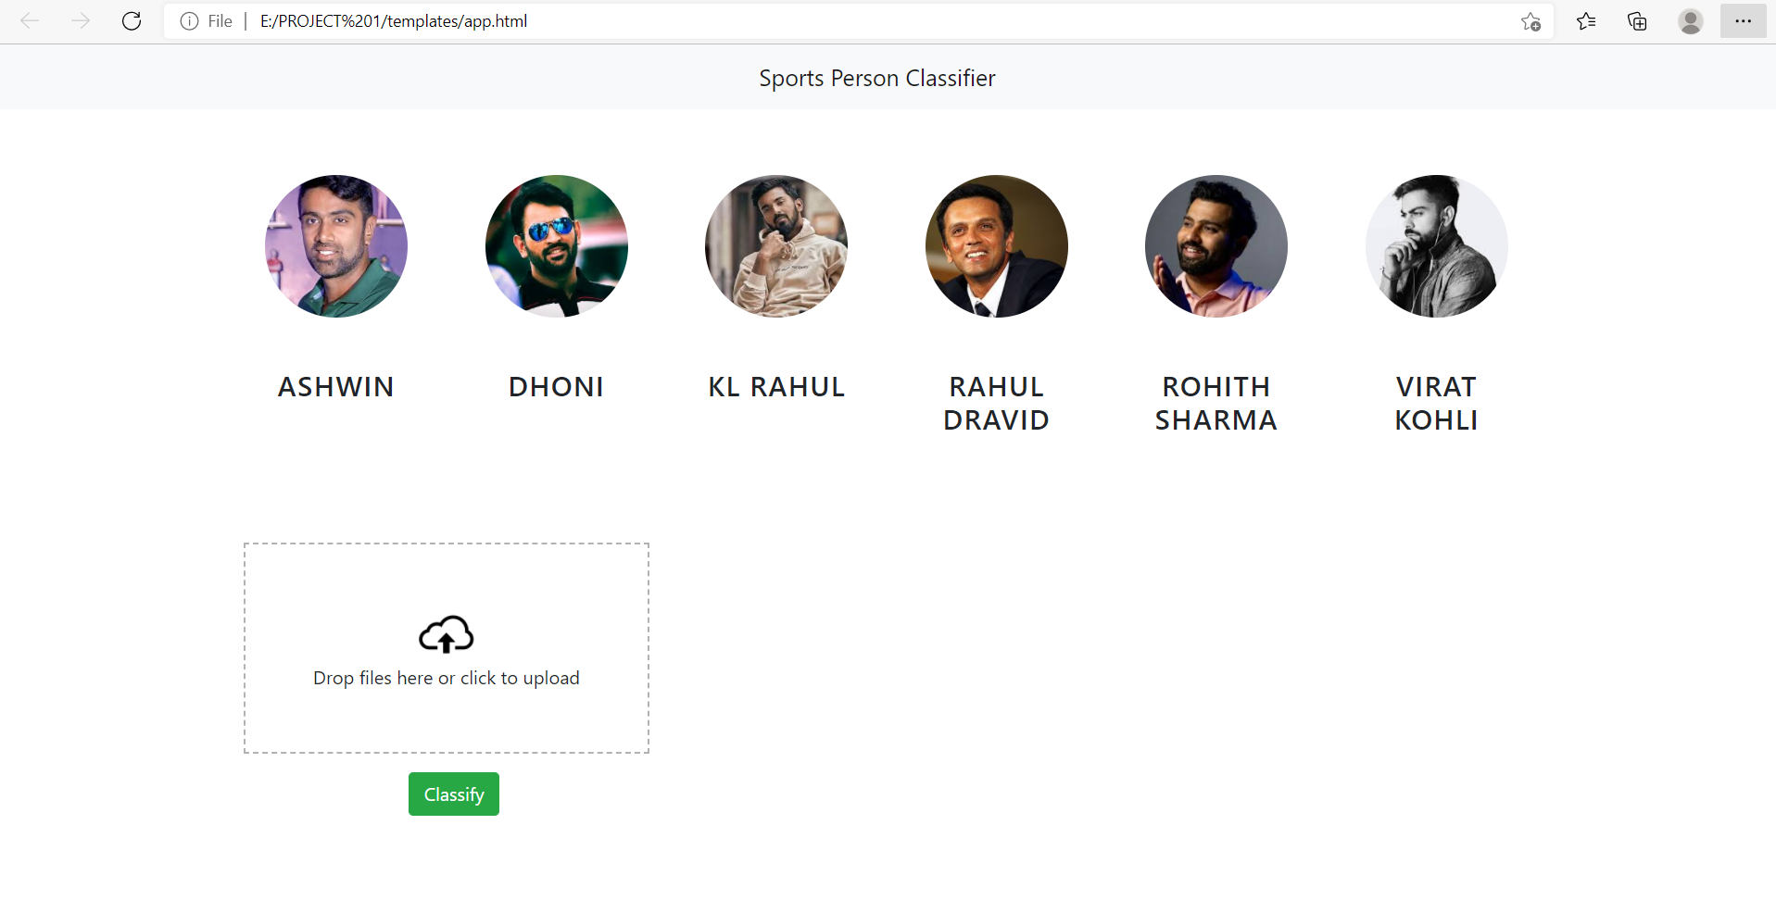

**Interface of the web page**

* The result of the uploaded is shown in below image

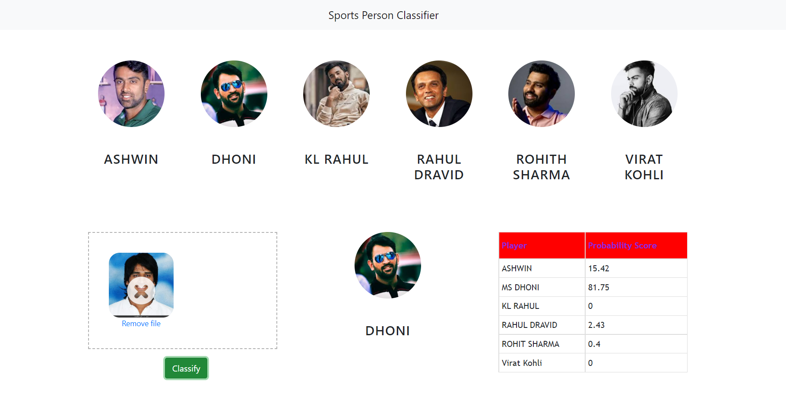

* Uploaded image is Dhoni and our web page shows the result that uploaded image belongs to Dhoni because those facial features are similar to Dhoni and our model predicted the image with an accuracy of 81.75%

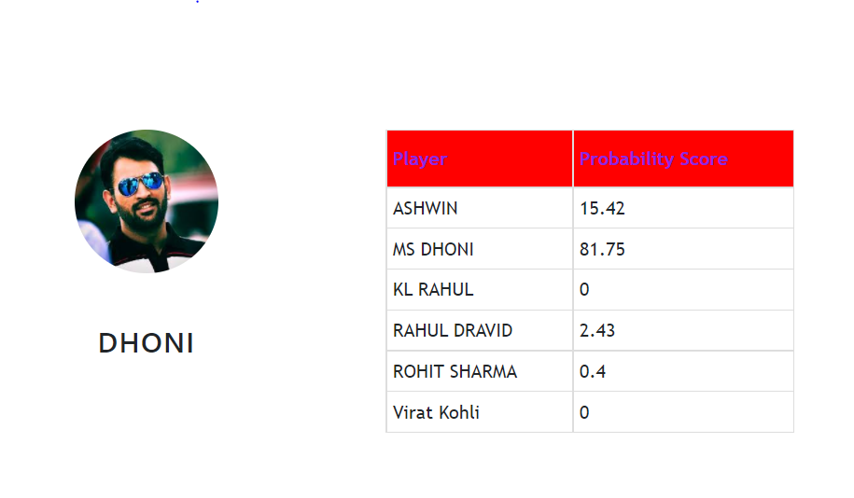

**Result**